8/20/2020

Mahmood Yousaf

2018-uet-nml-cs-11

**Learning Management System Project**

**ERD Diagram**

**(Due to some file size issues I am sharing my ERD diagram in Google drive link)**

[**Click here to view ERD Diagram for Project**](https://drive.google.com/file/d/1jlNAhjqku1UDssTtuKAQaEVRw2mK8MR_/view?usp=sharing)

**Converting ERD into Relational Database Tables**

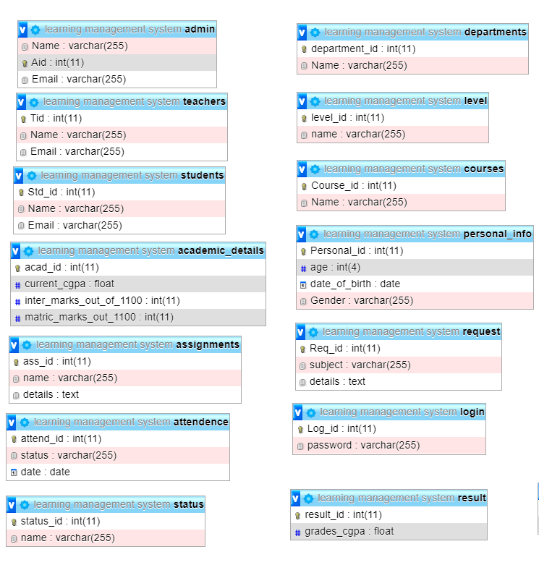

**Converting ERD into Relational Database Tables**

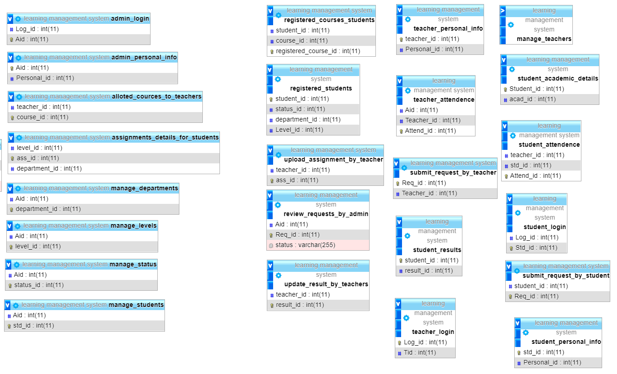

**Learning Management System Panel**

* **Bootstrap 4 is used to design the UI for Learning Management System**
* **User will interact with navigation bar to further proceed**

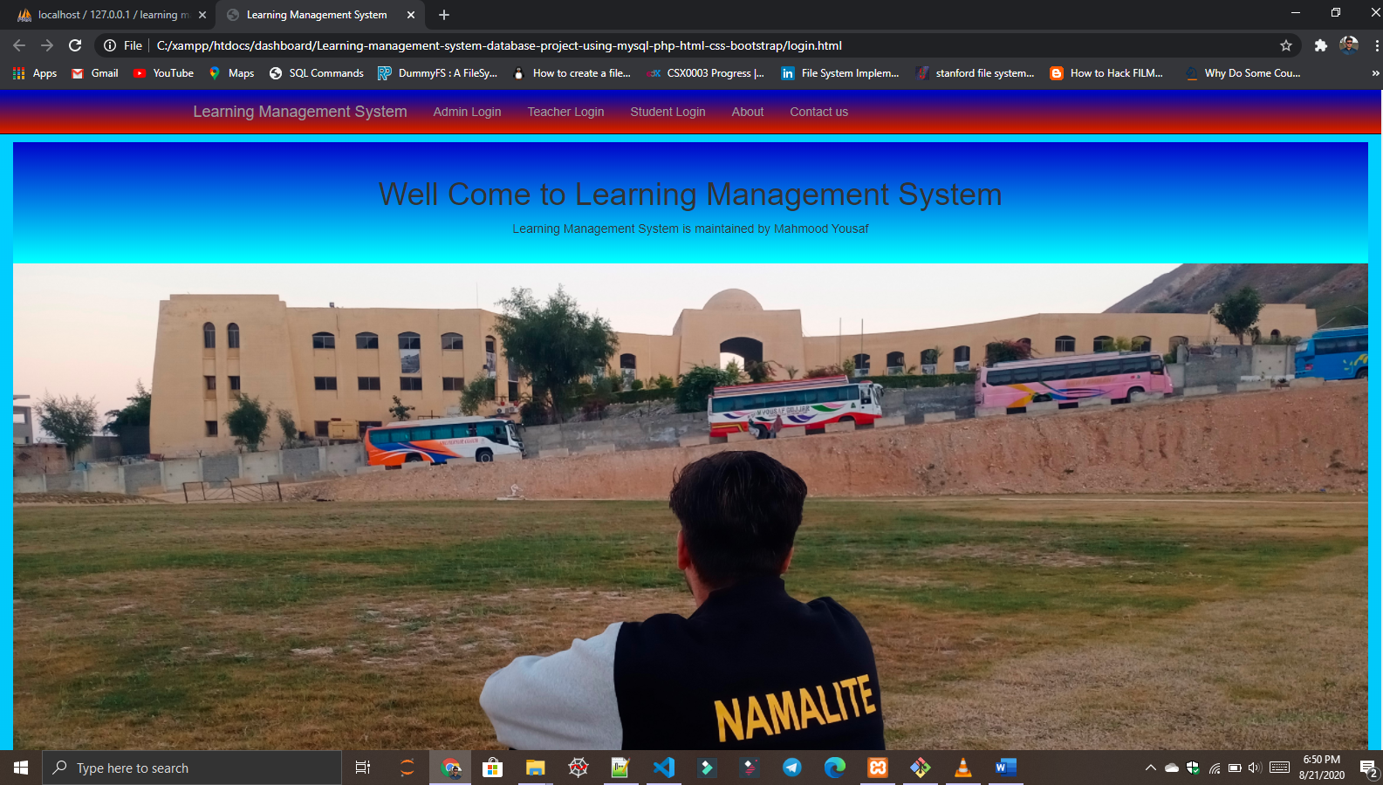

**Admin Module Implementation**

**Admin Login**

* **When user click on Admin login button on navigation bar than scroll will down to Admin Login space automatically**
* **Scroll is under controlled by Navigation bar**
* **This login table is connected with admin_login table in MySQL**
* **Admin_login table is reference to Admin and Login table by foreign keys to validate the Admin**
* **Admin will provide Email and password to login LMS**

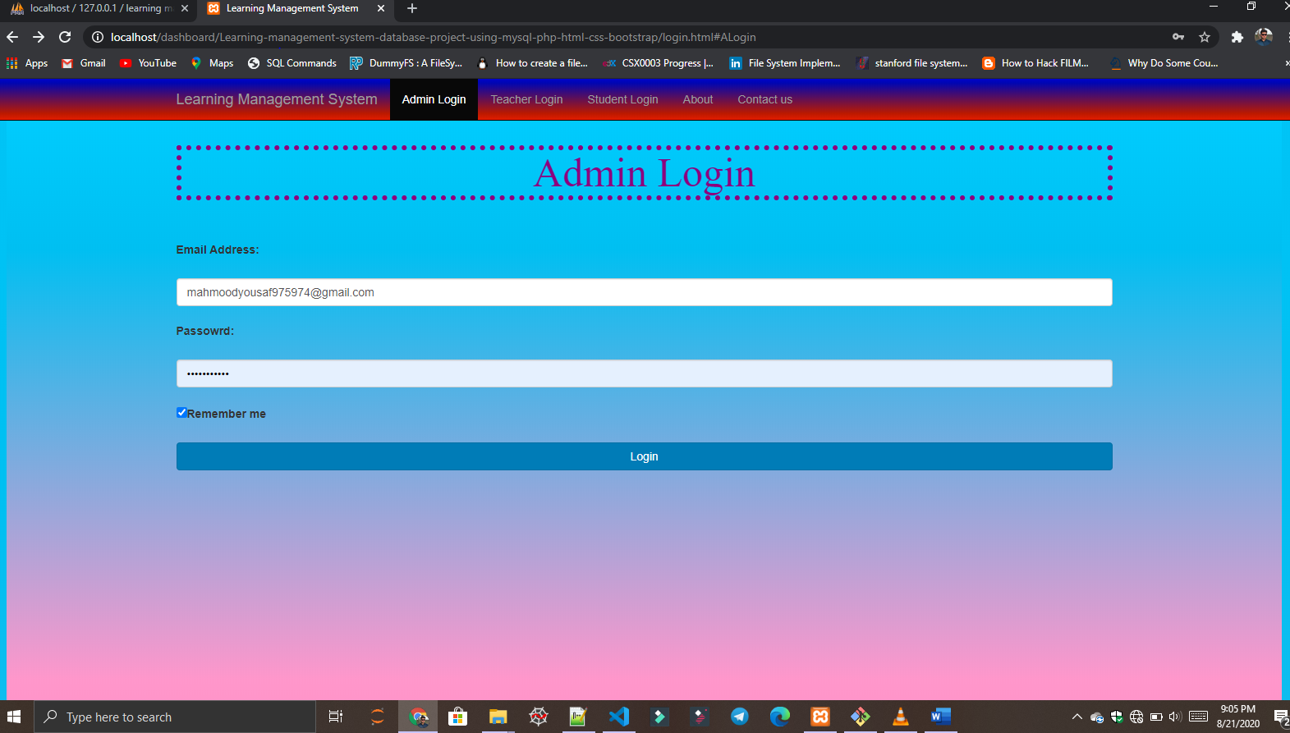

**Admin Panel**

* **When Admin is login successfully than admin is redirected to panel**
* **Admin can manage students, teachers, attendance, courses, class and section by using Navigation bar**
* **When admin clicks to any button than scroll is down to required space because Scroll is controlled by Navigation bar**

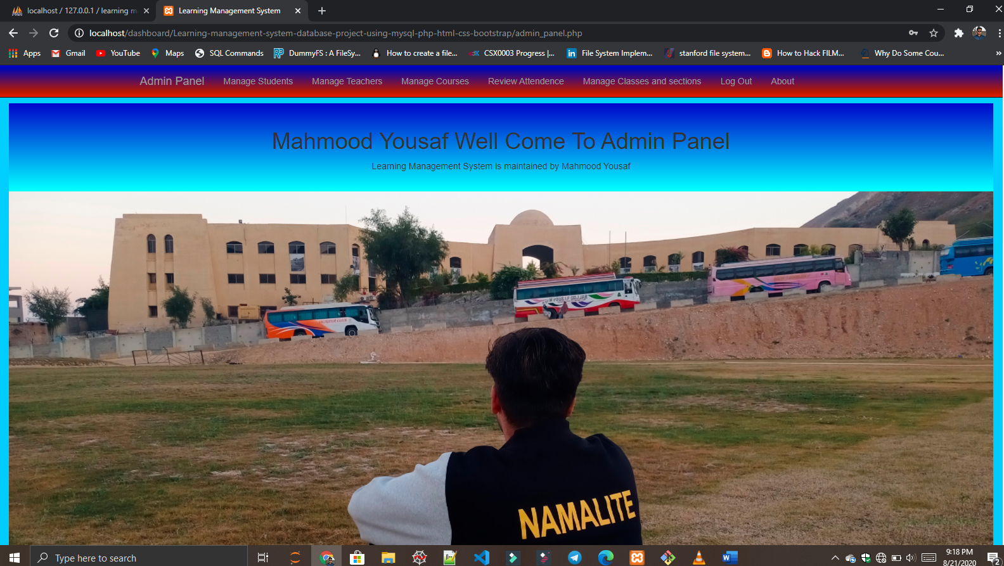

**Manage Students**

* **When Admin clicks on Manage Students than scroll will down automatically to manage students space**
* **Admin can add students, display all students, delete any student record and search any student record**
* **Manage student is connected manage_student table in MYSQL database**

**Add student record**

* **To add student record in student table. Insert query is used to add record in student table**
* **Provide all requried values to form than after click button form PHP will manage to run insert query in database**

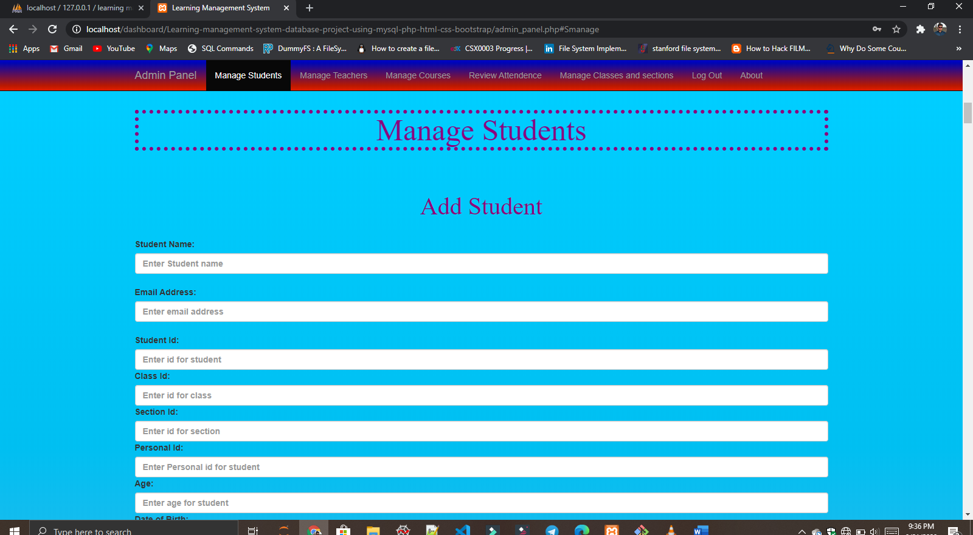

**Display, delete and search student records**

* **This view is connected to manage_student table to display, delete and search students in table**
* **When Admin clicks on button than form data is send to PHP to process the data and run query**

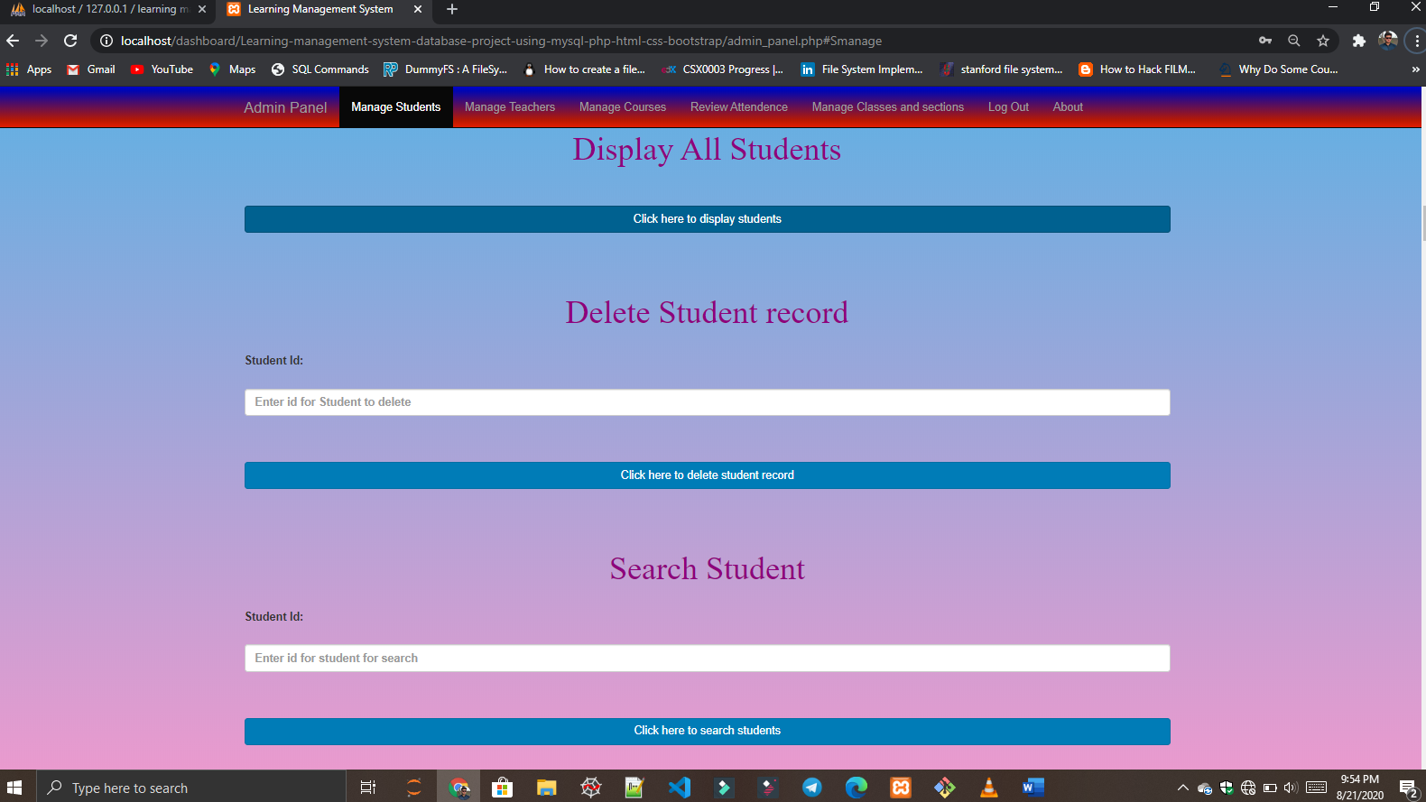

**Manage Teachers**

* **When Admin clicks on Manage Teachers than scroll will down automatically to manage teacher space**
* **Admin can add teachers, display all teachers, delete any teacher record and search any teacher record**
* **Manage teachers is connected manage_teachers table in MYSQL database**

**Add teacher record**

* **To add teacher record in teacher table. Insert query is used to add record in teacher table**
* **Provide all requried values to form than after click button form PHP will manage to run insert query in database**

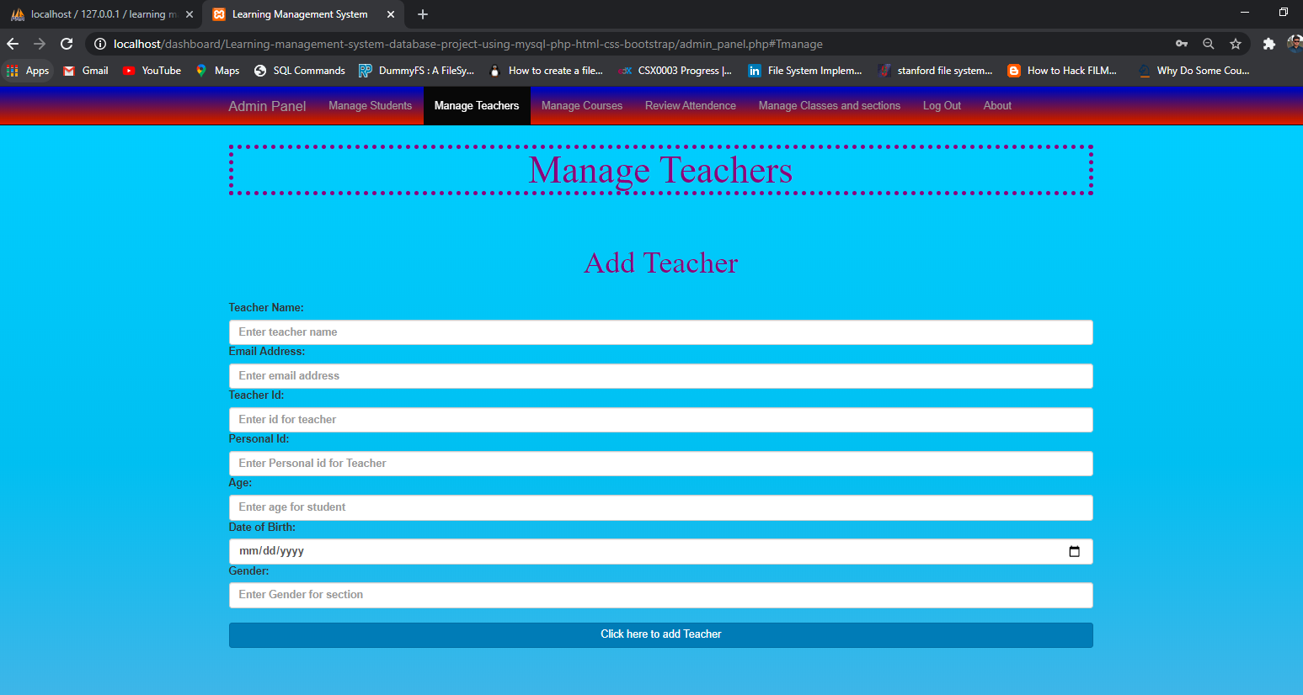

**Display, delete and search teacher records**

* **This view is connected to manage_teacher table to display, delete and search teacher in table**
* **When Admin clicks on button than form data is send to PHP to process the data and run query**

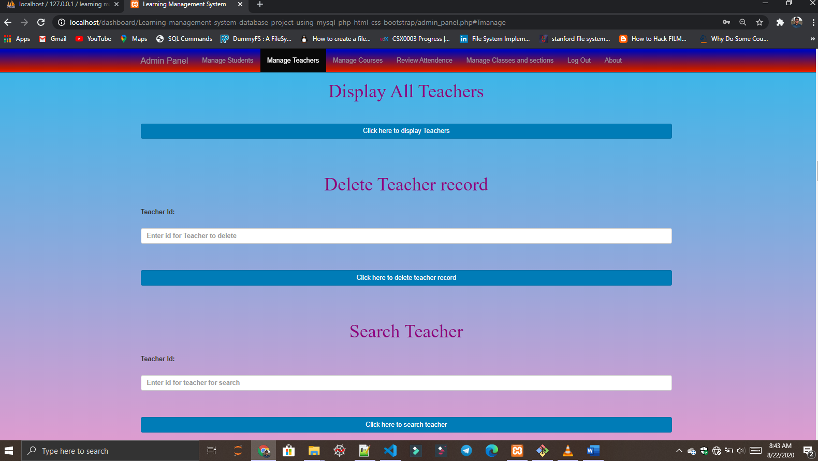

**Manage Courses**

* **When Admin clicks on Manage Courses than scroll will down automatically to manage Courses space**
* **Admin can add Course, display all Courses, delete any Coure record and search any Course record**
* **Manage Courses is connected manage_Courses table in MYSQL database**

**Add Course record**

* **To add Course record in Course table. Insert query is used to add record in Course table**
* **Provide all requried values to form than after click button form PHP will manage to run insert query in database**

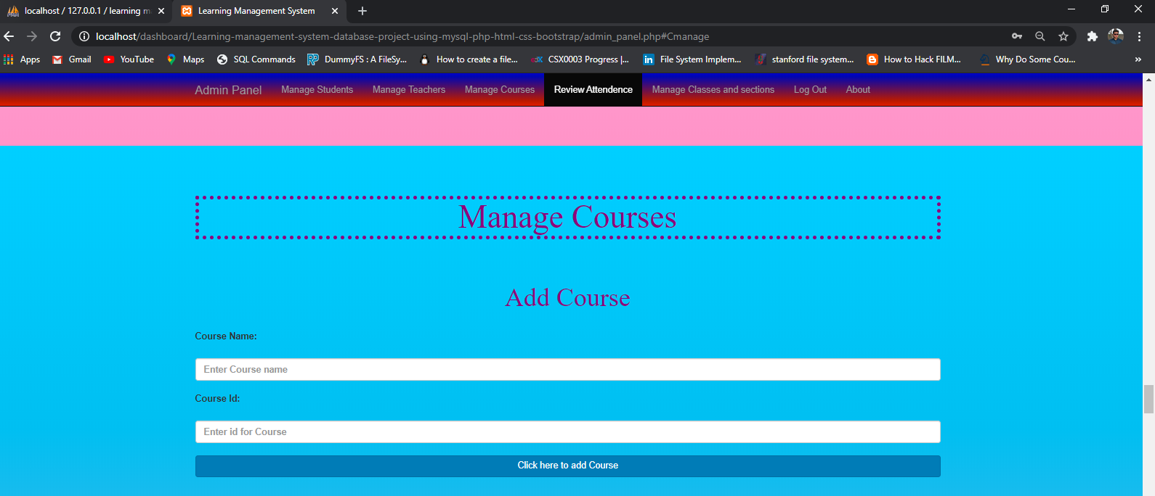

**Display, delete and search Course records**

* **This view is connected to manage_course table to display, delete and search Courses in table**
* **When Admin clicks on button than form data is send to PHP to process the data and run query**

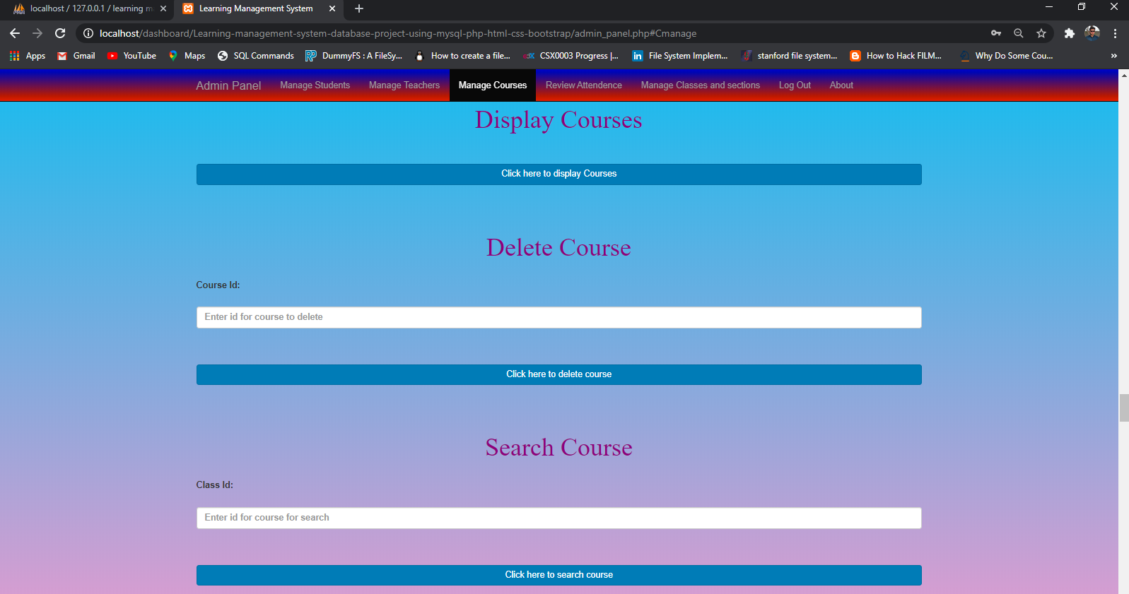

**Review Attendence**

* **When Admin clicks on Review Attendence than it contain dropdown menue**
* **Dropdown menue have Students and Teachers Section**

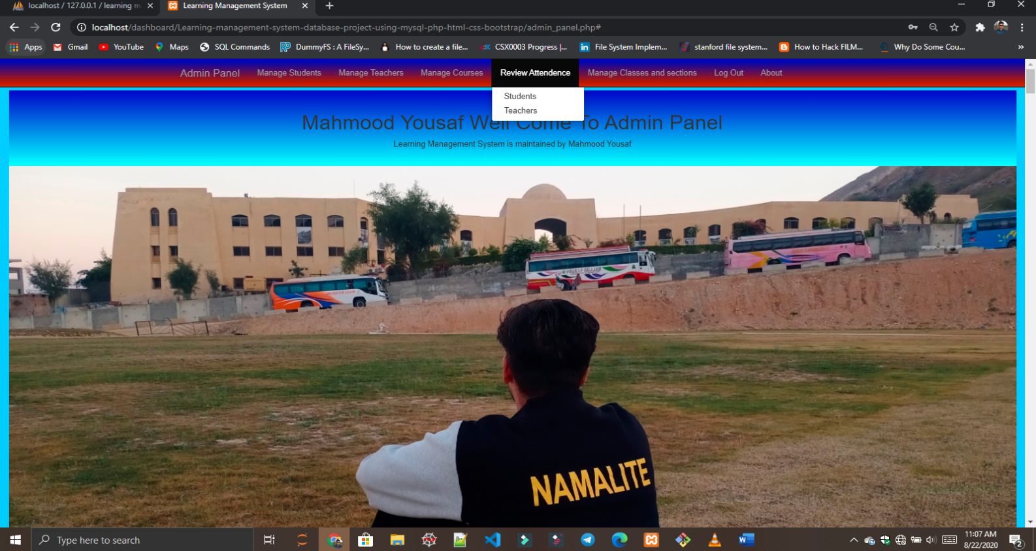

**Review Student Attendence**

* **When Admin clicks on Student in dropdown menue**
* **Scroll will down automatically to Student Attendence Review space**
* **Admin can update any student attendence, delete any student attendence and Search any student attendence**
* **Review Student Attendence is connected to student_attendence table in database MYSQL**

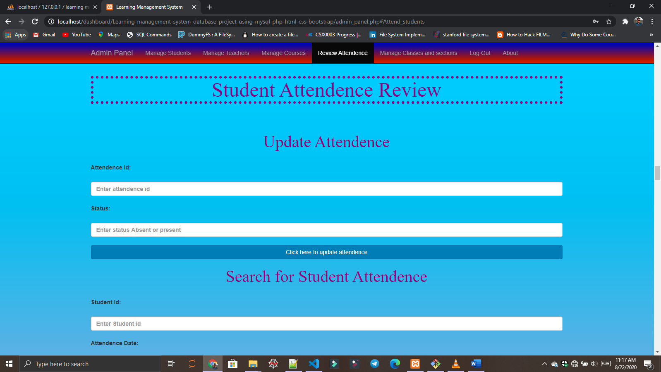

**Review Teacher Attendence**

* **When Admin clicks on Teacher in dropdown menue**
* **Scroll will down automatically to Teacher Attendence Review space**
* **Admin can update any Teacher attendence, delete any Teacher attendence and Search any Teacher attendence**
* **Review Teacher Attendence is connected to teacher_attendence table in database MYSQL**

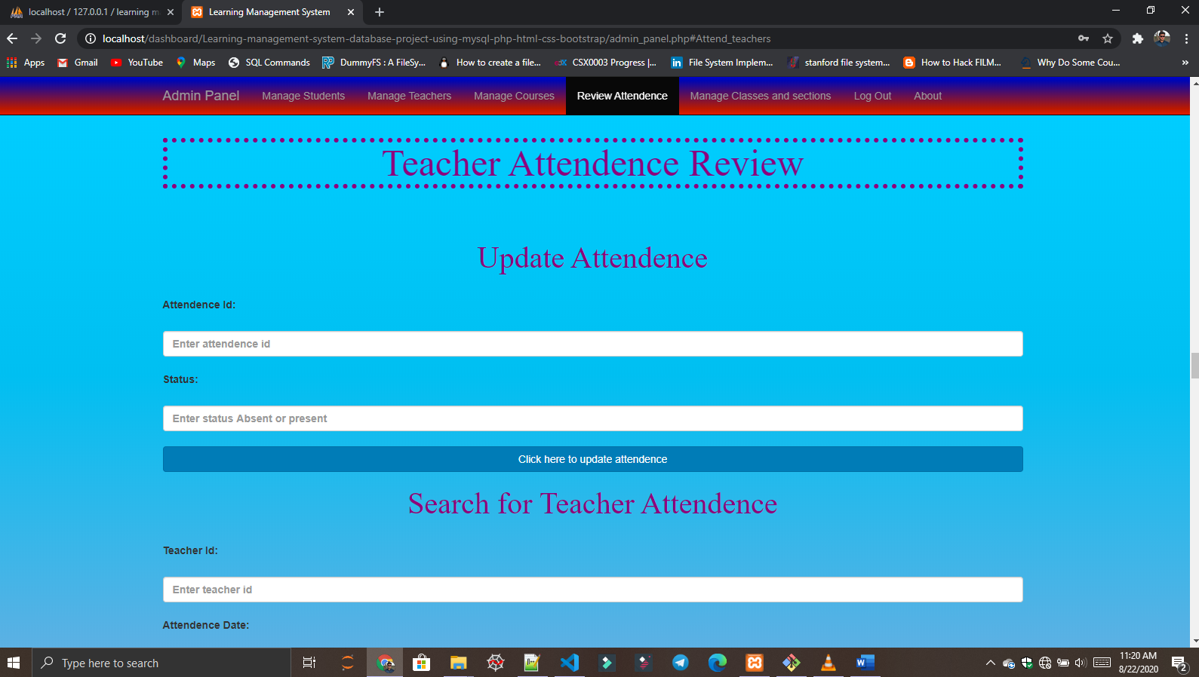

**Manage Classes and Sections**

* **When Admin clicks on Manage Classes and Sections than it contain dropdown menue**
* **Dropdown menue have Classes and Sections Items**

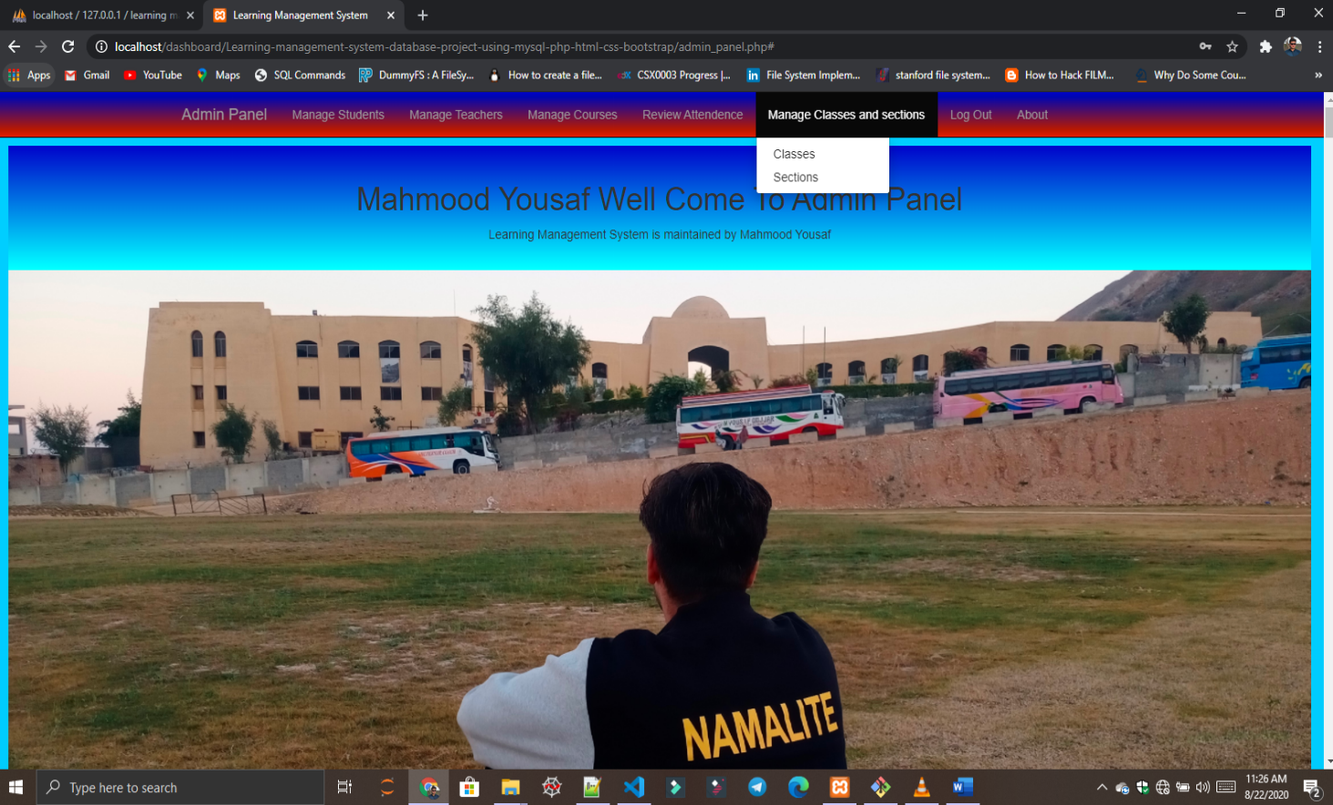

**Manage Classes**

* **When Admin clicks on Classes in dropdown menue**
* **Scroll will down automatically to Manage Classes space**
* **Admin can add Class, display all Classes, delete any Class record and search any Class record**
* **Manage Classes is connected manage_classes table in MYSQL database**

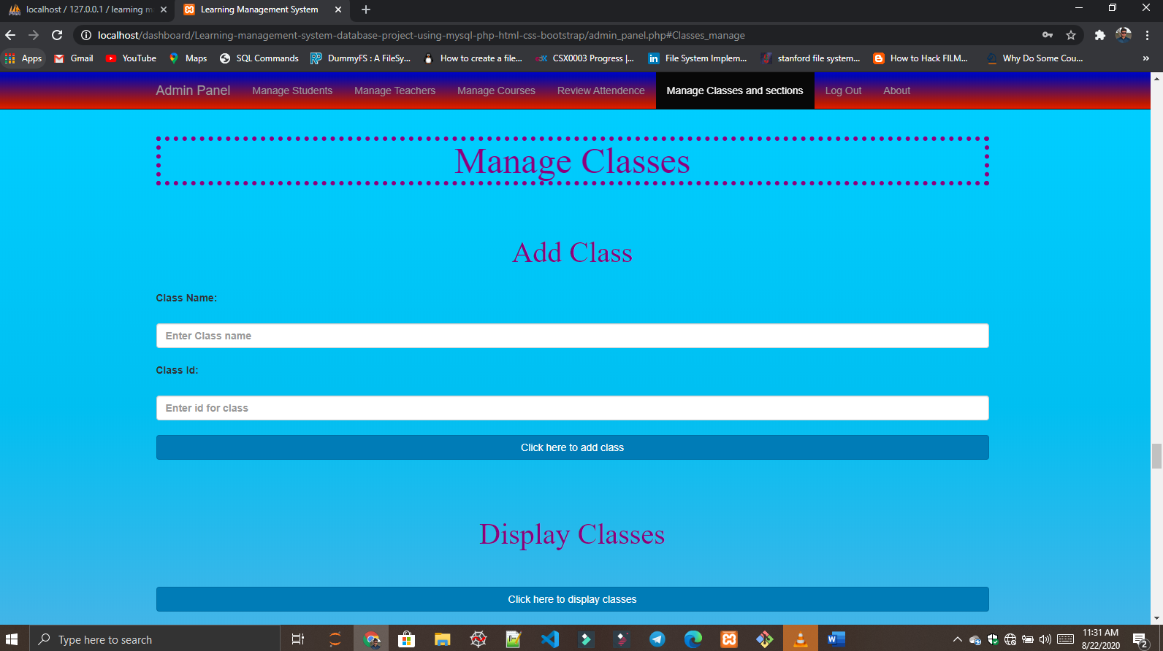

**Manage Sections**

* **When Admin clicks on Sections in dropdown menue**
* **Scroll will down automatically to Manage Sections space**
* **Admin can add Section, display all Sections, delete any Section record and search any Section record**
* **Manage Sections is connected manage_sections table in MYSQL database**

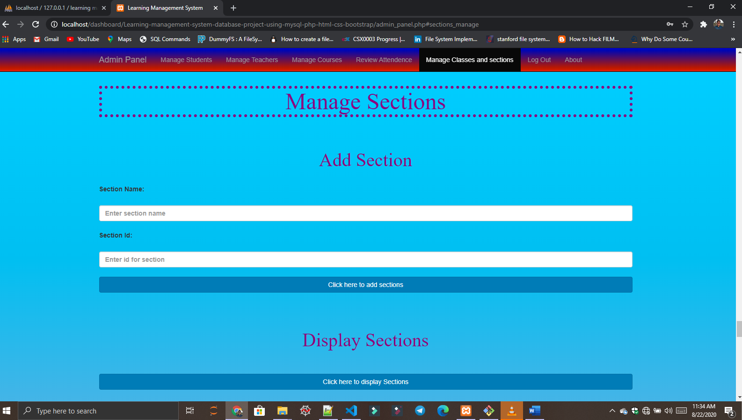

**Logout**

* **When Admin clicks on Logout in Navigation bar**

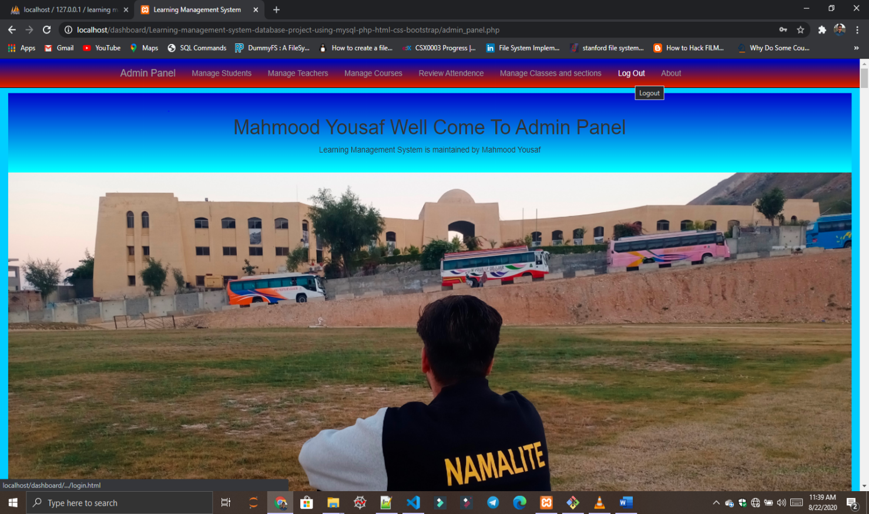

**Redirect to Login Page**

* **When Admin clicks on Logout in Navigation bar**
* **Admin will logout Successfully and will redirected to Learning Management System Panel**

